Printing Team Roster and Emailing Team inside TCBSA website (tcbasesoft.com)

Log into your account on tcbasesoft.com, the same place where you register your child. Once logged in, navigate to the team name next to your child’s name.

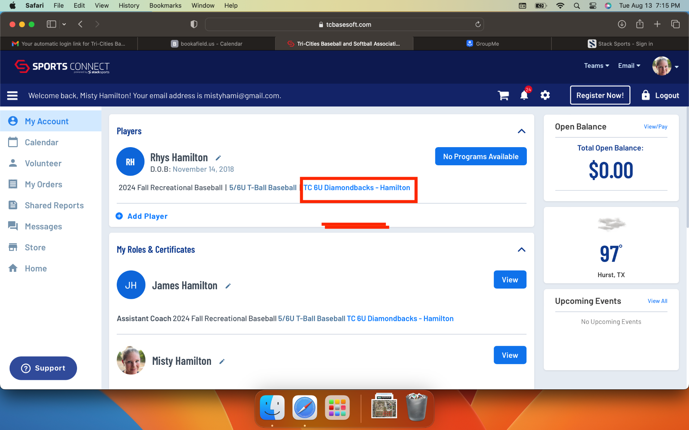

This takes you to Team Central where your team directory, etc is located. When you scroll down, the second option from the left is Roster. This is where you can see your team and assigned assistant coaches.

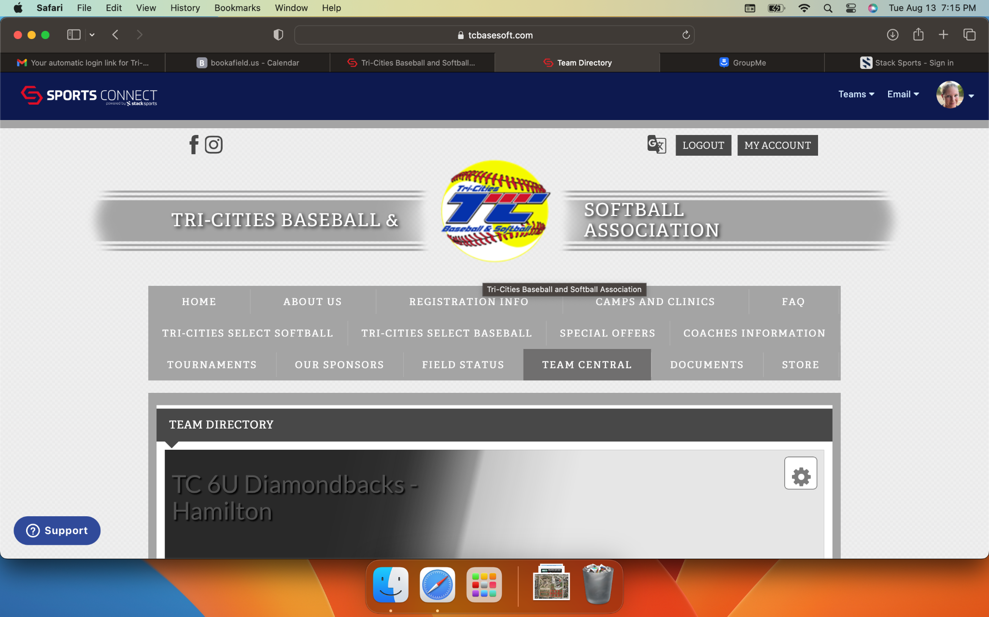

From here you can generate your roster with numbers, names, parents, contact, etc.

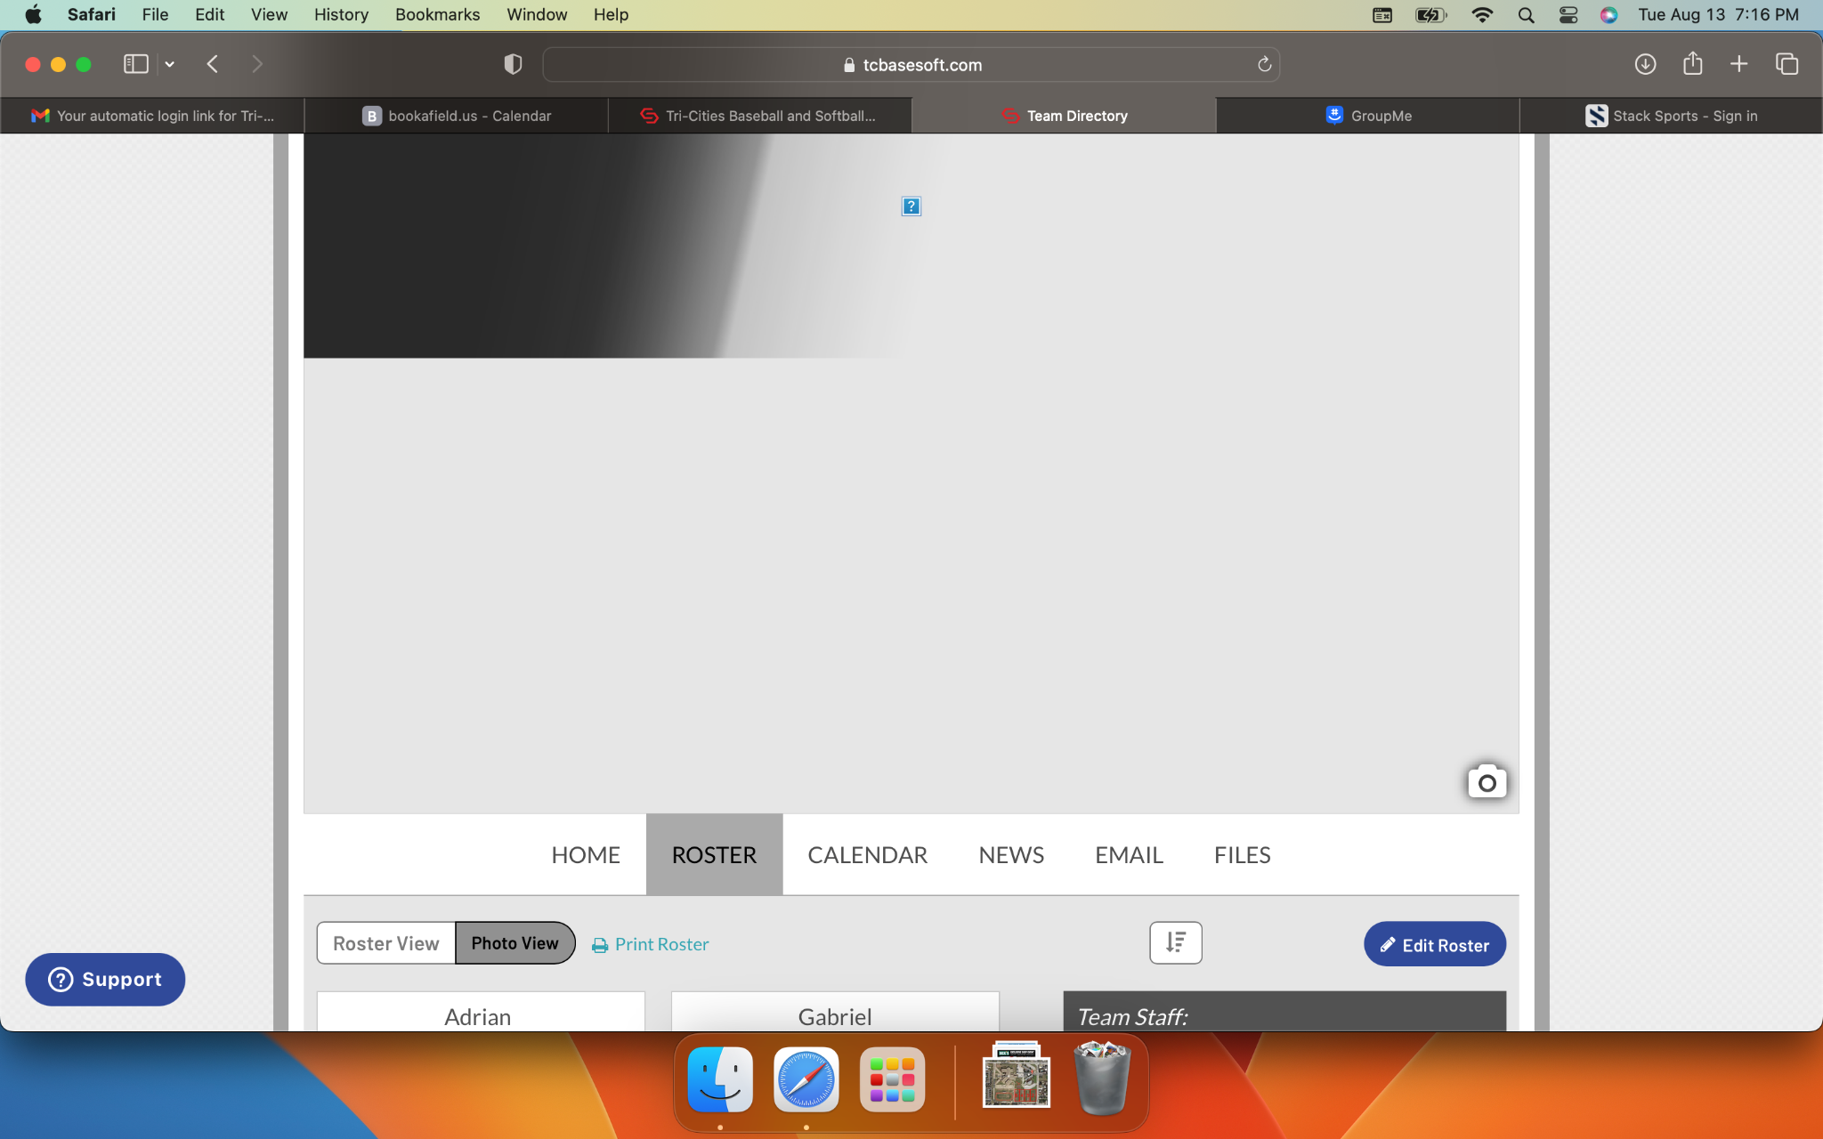

Select Print Roster in blue
Select which options you want on your report and click Generate Report.

Your report will display at the bottom of the page. On the left will be a blue button to Export, the drop down gives you options of excel, pdf, google drive, and rich text format. In the gray bar under that, on the right is a print icon to print what is displayed.

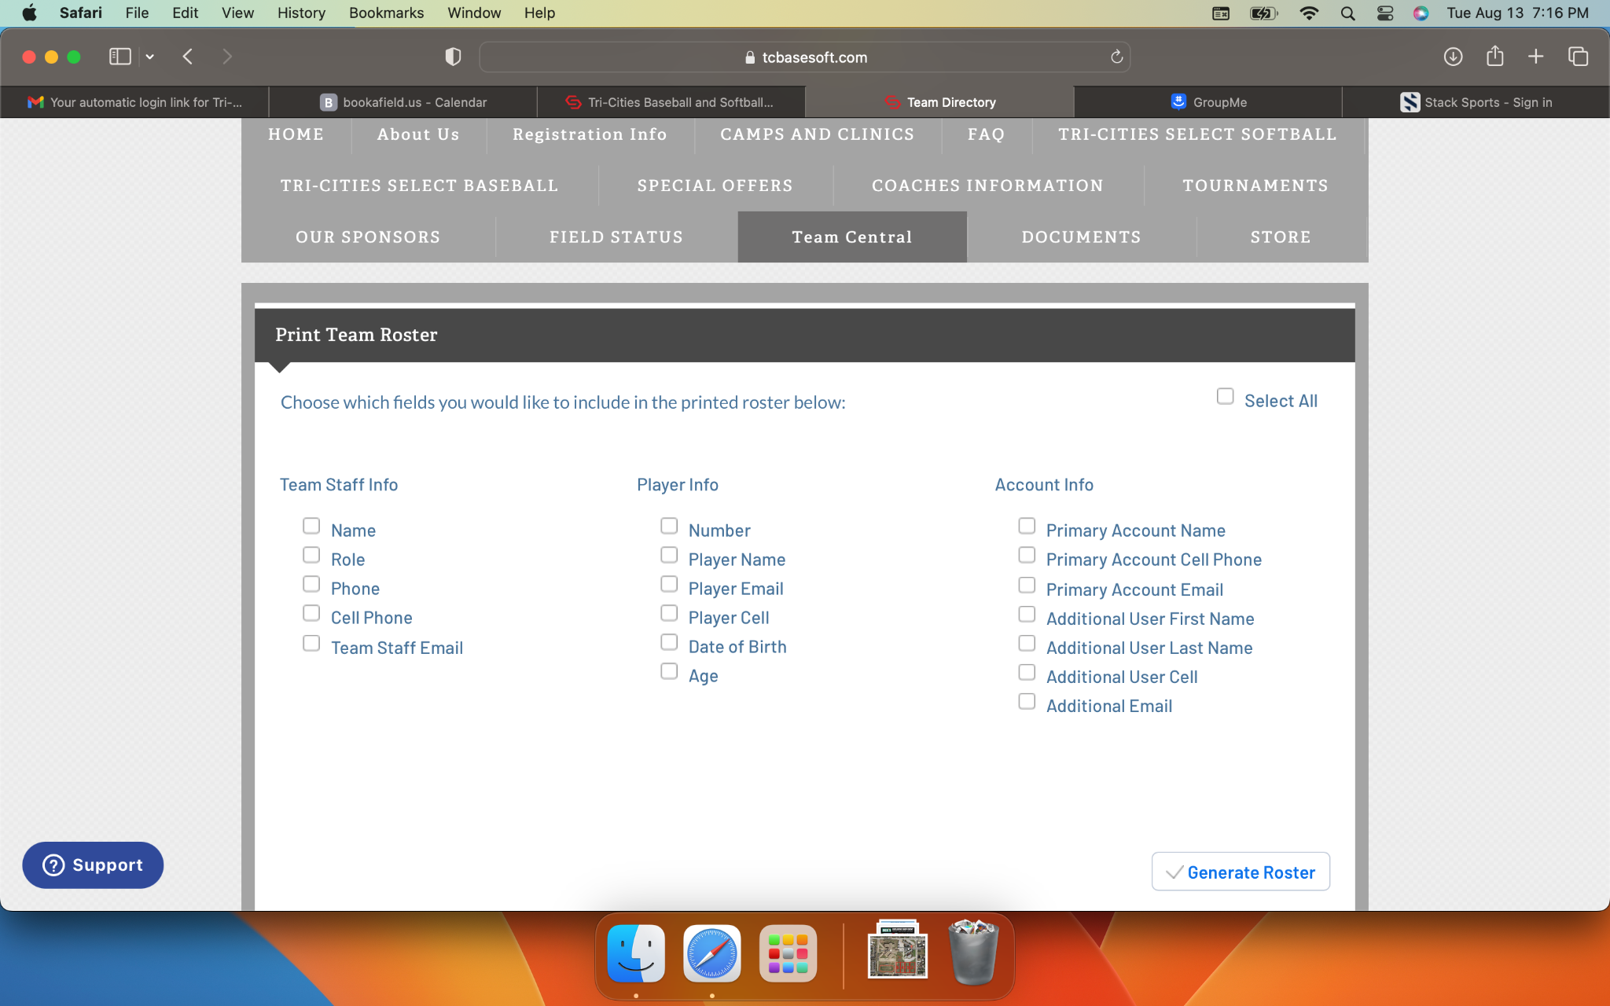

Emailing parents from team directory

In the team directory, EMAIL is the second option from the right. This is where you can send emails. You can add 1 attachment to the email. Then select all or select specific people, etc to receive email. Then click send.

